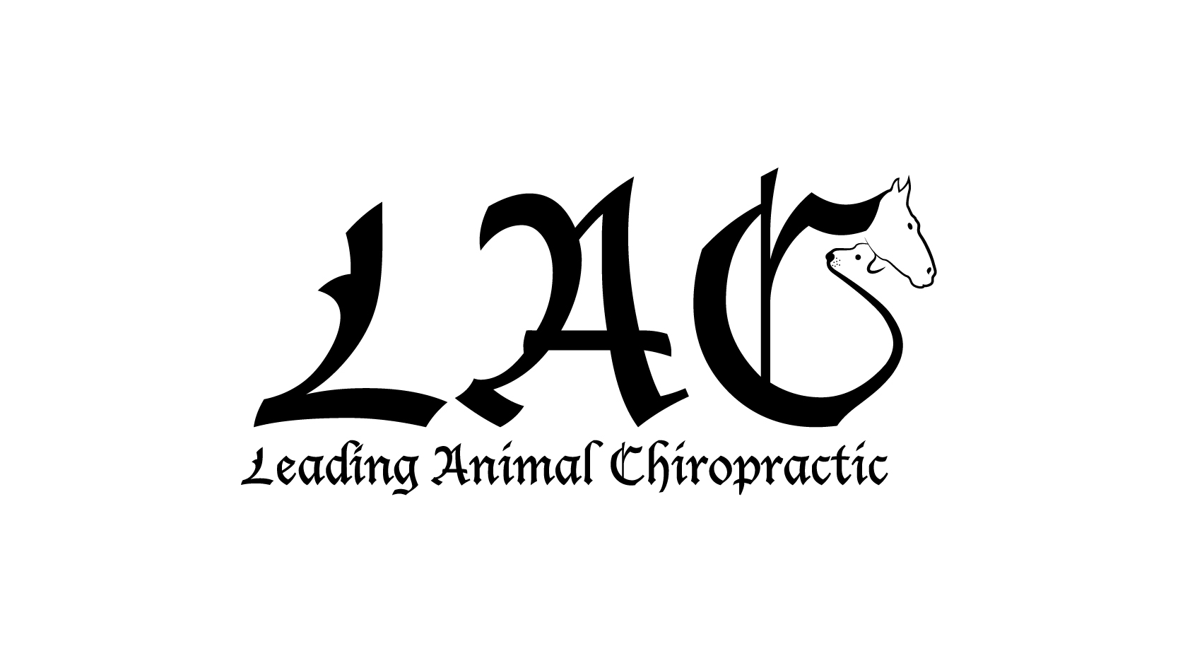
Request for Veterinary Referral and Client Consent

Date: ______________

Client’s Name: ____________________________

Patient’s Name: ___________________________

Species: _________________________________ Breed: _______________________________

Veterinarian’s name: _______________________

Contact Number: __________________________ Contact Email: _________________________

Fax: ____________________________________

Leading Animal Chiropractic: Dr. Brooke Kelly: DC, Certified Animal Chiropractor, AVCA Certified
Contact Number: 208-350-3260 Contact Email: DrBrookeKelly@gmail.com (preferred)

Client (pet owner)

• Client requests a referral from the veterinarian for animal chiropractic care to be administered by the animal chiropractor, who is a licensed Chiropractor in the State of Texas and is certified in Animal Chiropractic.

• Although Chiropractic treatment is an alternate therapy in veterinary medicine, Client approves its use in the treatment of the animal. Client has been informed of the conventional treatments available and their probably ability to cure the problem.

• Client understands that no guarantees can be made for the outcome of treatment.

Referring Veterinarian

In compliance with Texas Administrative Code Rule 573.12:

• Veterinarian has a valid veterinarian/patient relationship with the Client and this animal.

• Veterinarian has performed an examination to determine that chiropractic will not likely be harmful to the animal.

•Veterinarian will provide direct or general supervision of the animal’s treatment and will use the level of professional judgment as would be exercised by the average Texas veterinarian who performs or recommends chiropractic treatments in their practice.

• This signed statement is a permanent part of the patient’s record, and is the consent form to treat the animal.

Client Signature: ________________________________________ Date:_______________________

Veterinarian Signature: ______________________________________ Date:_______________________

Please Note: I must have this form – complete with signatures- before I can see your animal. All records are welcome as well to be added to your animal’s file. Bring this with you to the first appointment. Thank you! –Dr. Brooke Kelly

